UCS503 – Software Engineering
ScholarLink
An LLM-Powered Platform for Research Discovery, Topic Extraction, and Academic Collaboration
Submitted by:
1024240042 Hemant Chugh
1024240058 Diljeet Kaur
1024240035 Saurabh Shivhare
1024240061 Divyam
Branch: Artificial Intelligence & Machine Learning
Submitted to:
Anushka Chaudary
Department of Computer Science and Engineering
Mid-Semester Evaluation
Computer Science and Engineering Department
Thapar Institute of Engineering and Technology, Patiala

Contents
1 Introduction 3
1.1 Background and Context 3
1.1.1 Problem Statement 3
1.2 Project Objectives 3
2 Methodology and Design 5
2.1 System Architecture 5
2.1.1 High-Level Design 5
2.1.2 Technical Stack 5
2.1.3 Use Case Diagram 6
2.1.4 Class Diagram / Domain Model 6
2.2 Implementation Details 7
2.2.1 Module 1: Core Functionality 7
2.2.2 Module 2: Secondary Features 7
2.2.3 Sequence Diagram 8
3 Results and Evaluation 9
3.1 Testing Methodology 9
3.2 Performance Metrics 9
3.3 Analysis 9
4 Conclusion 11
4.1 Summary of Work 11
4.2 Key Findings 11
4.3 Future Work and Recommendations 11
4.4 Final Remarks 11
Bibliography 13

Chapter 1 Introduction

1.1 Background and Context
Research and project work produced within an academic department is often scattered across personal drives, email threads and printed submissions, leaving no shared, searchable record of who is working on what. A junior student looking for a mentor, or a student wishing to build on a senior's project, has no reliable way to discover relevant prior work beyond word of mouth. ScholarLink is proposed as a web platform on which professors and students publish research papers and project reports, tag co-authors, and build a public academic profile. A large language model (LLM) is intended to read each uploaded paper to automatically extract the topics or domains it belongs to and generate a concise summary of the future scope of work identified in it, so that other students can discover relevant work by topic and reach out to the original authors for guidance or collaboration.
This report documents the mid-semester status of the project: the foundation of the system — authentication, role management, the paper-upload pipeline, PDF text extraction, duplicate-upload protection, automated testing and a redesigned frontend — has been implemented and is demonstrated in the current prototype. The LLM-based topic-extraction and future-scope-generation pipeline, together with the collaboration-request and notification workflows, are designed into the data model but are scheduled for the next phase of development, as detailed in Chapter 3 and Chapter 4.

1.1.1 Problem Statement
Departments lack a lightweight, searchable system that connects published student and faculty research to the people best placed to extend it. Existing repositories — departmental drives, printed archives, or general platforms such as ResearchGate and Google Scholar — either require heavy manual curation, are aimed at a global scale outside a single academic department, or provide no structured way to identify a paper's future scope and no built-in mechanism for a junior student to request mentorship from a specific author. There is a need for a system in which uploading a paper automatically classifies it by topic, surfaces what work remains open, and lets interested students contact the right person directly from the paper's page.

1.2 Project Objectives
The following objectives were set out at proposal stage. The status noted against each reflects progress at the time of this mid-semester evaluation.
- Build a role-based web application (Student, Professor, Admin) with secure JWT authentication. — Completed.
- Allow professors and students to upload research papers/project reports and tag co-authoring students at upload time. — Completed.
- Integrate an LLM pipeline that extracts text from the uploaded PDF and returns structured topic tags and a future-scope summary. — PDF text extraction completed; LLM-based topic and future-scope extraction planned for the next phase.
- Provide topic-based search and browse so students can discover papers relevant to their interests. — Researcher/user search completed; topic-based paper search planned once topic extraction is in place.
- Build a public profile page for every user summarising their past papers/projects. — Profile page implemented in the frontend; full data population is planned.
- Implement a collaboration-request workflow with in-app notifications. — Data model in place; workflow implementation planned for the next phase.
- Follow test-driven development and automate build-test-deploy with CI/CD. — TDD followed for completed modules (30 tests passing); CI/CD scaffolding in progress.

Chapter 2 Methodology and Design

2.1 System Architecture

2.1.1 High-Level Design
ScholarLink is designed as a three-tier web application. A React (Vite) frontend provides role-specific screens for authentication, the dashboard, paper upload, researcher search and user profiles. A FastAPI backend exposes REST endpoints and enforces business rules through a Route → Service → Repository layering, which keeps business logic out of route handlers and keeps the layers independent of one another — for example, the LLM provider used for topic extraction can later be changed without affecting the routing or data-access layers. PostgreSQL is the system of record, with SQLAlchemy handling ORM mapping and Alembic managing schema migrations.
The domain model centres on eight entities: User, Paper, PaperAuthor, Topic, PaperTopic, PaperInsight, CollaborationRequest and Notification. A Paper has one or more PaperAuthor links representing the uploading user and any tagged co-authors. Topic and PaperTopic exist to support topic-based classification, PaperInsight is reserved for the LLM-generated summary and future-scope text, and CollaborationRequest and Notification together support the mentorship-request workflow. The initial Alembic migration has established this schema, including relationships, foreign keys, unique constraints and PostgreSQL enum types, so that the remaining modules can be built directly on top of it.

2.1.2 Technical Stack
Layer | Technology | Status
Frontend | React + Vite, React Router | Implemented
Backend API | FastAPI (Route → Service → Repository) | Implemented
ORM / Migrations | SQLAlchemy, Alembic | Implemented
Database | PostgreSQL | Implemented
Authentication | JWT, bcrypt password hashing | Implemented
PDF Processing | PyMuPDF (text extraction) | Implemented
Testing | pytest, TDD (red → green → refactor) | Implemented
Containerisation / CI-CD | Docker, docker-compose, GitHub Actions | In progress
LLM Layer | Claude / OpenAI API for topic and future-scope extraction, async worker queue | Planned
Search | PostgreSQL full-text search; pgvector semantic search (stretch goal) | Planned

2.1.3 Use Case Diagram
Figure 2.1 shows the primary actors — Student, Professor and Admin — and the use cases they interact with inside the ScholarLink system boundary. Register/Login, Upload Paper, Tag Co-Authors, Search Researchers and View Profile are implemented and drawn with solid outlines. Request Collaboration, View Notifications and LLM-Based Topic Extraction are designed into the data model but scheduled for the next phase of development, and are drawn with dashed outlines to distinguish planned functionality from what is already built.
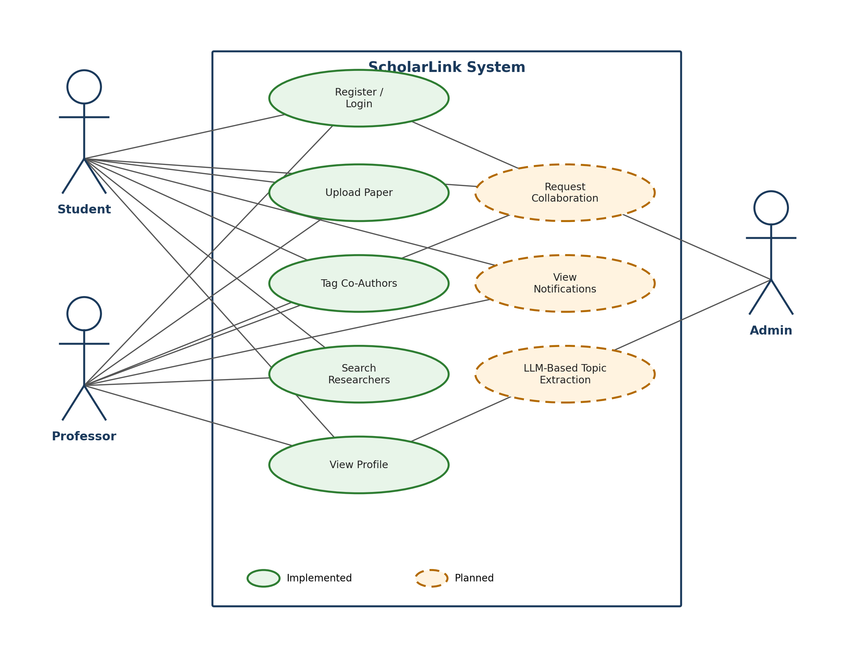
Figure 2.1: Use case diagram — Student, Professor and Admin actors against implemented (solid) and planned (dashed) use cases.

2.1.4 Class Diagram / Domain Model
Figure 2.2 expands the eight-entity domain model introduced in Section 2.1.1 with full attributes and relationship cardinalities, colour-coded by implementation status. User, Paper and PaperAuthor (green headers) are implemented in both schema and application logic. Topic, PaperTopic, PaperInsight, CollaborationRequest and Notification (amber headers) already have their schema established by the initial Alembic migration, but the logic that populates and consumes them — topic extraction, insight generation, and the collaboration/notification workflow — is planned for the next phase.
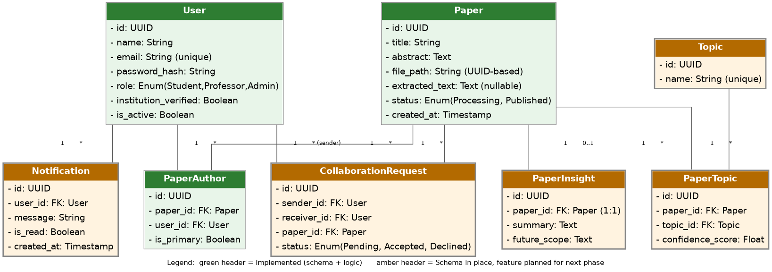
Figure 2.2: Class diagram / domain model — green headers denote entities implemented in schema and logic; amber headers denote entities whose schema is in place but whose feature logic is planned.

2.2 Implementation Details

2.2.1 Module 1: Core Functionality
Authentication and Authorisation. The registration endpoint creates user accounts and rejects duplicate-email registrations. Login issues a JWT used for all protected routes, and passwords are stored using bcrypt hashing rather than plaintext. Role-based access control distinguishes Student, Professor and Admin roles, with administrative operations covering institutional-email verification and account deactivation.
Paper Upload Pipeline. An authenticated user submits a paper with a title, abstract, a PDF file (as multipart form data) and optional co-author identifiers, using Bearer JWT authentication. The request passes through the route, service and repository layers, and the uploaded file is stored under a UUID-based identifier to avoid filename collisions.
PDF Text Extraction. Text extraction from the uploaded PDF is implemented using PyMuPDF. A paper-specific extraction operation processes the document and stores the extracted text against the existing paper record; re-extraction updates the stored text rather than creating a duplicate paper, which is the entry point the subsequent LLM pipeline will build on.

2.2.2 Module 2: Secondary Features
Co-Author Search and Association. The frontend provides a debounced researcher-search field so co-authors can be found and selected without generating excessive requests while typing; selected co-authors can be added or removed before submission. The backend uses get-or-create logic for author links, which avoids duplicate association records when the same author is tagged more than once.
Duplicate-Upload Protection. Three independent safeguards were implemented: a frontend submission lock that prevents repeated clicks while an upload is in progress, a backend check that rejects a repeat upload from the same user with the same title within a short configurable window, and UUID-based file storage that removes filename-collision risk.
Frontend Redesign. A substantial redesign of the frontend was completed on a dedicated frontend-redesign branch, turning the original interface into a professional academic/SaaS-style design while preserving all existing upload functionality. The redesign covers the authentication screen and its branded visual panel, the dashboard layout with sidebar and top navigation, reusable statistic cards, research-paper cards, the researchers section, the paper-upload page, the profile page and responsive styling across breakpoints, together with the API integration needed to drive them (registration, login, current-user retrieval, researcher search and paper upload).

2.2.3 Sequence Diagram
Figure 2.3 traces the paper upload and text-extraction flow through the Route → Service → Repository architecture described in Section 2.1.1. The Service layer first asks the Repository to check for a duplicate title from the same user within a short window; if a duplicate is found, a 409 Conflict is returned to the Client and the flow ends, as shown in the alt frame. Otherwise the file is stored under a UUID-based name, the paper record is persisted with status Processing, and PyMuPDF extracts the text, which is written back to the paper record before a 201 Created response with the paper details is returned to the Client.
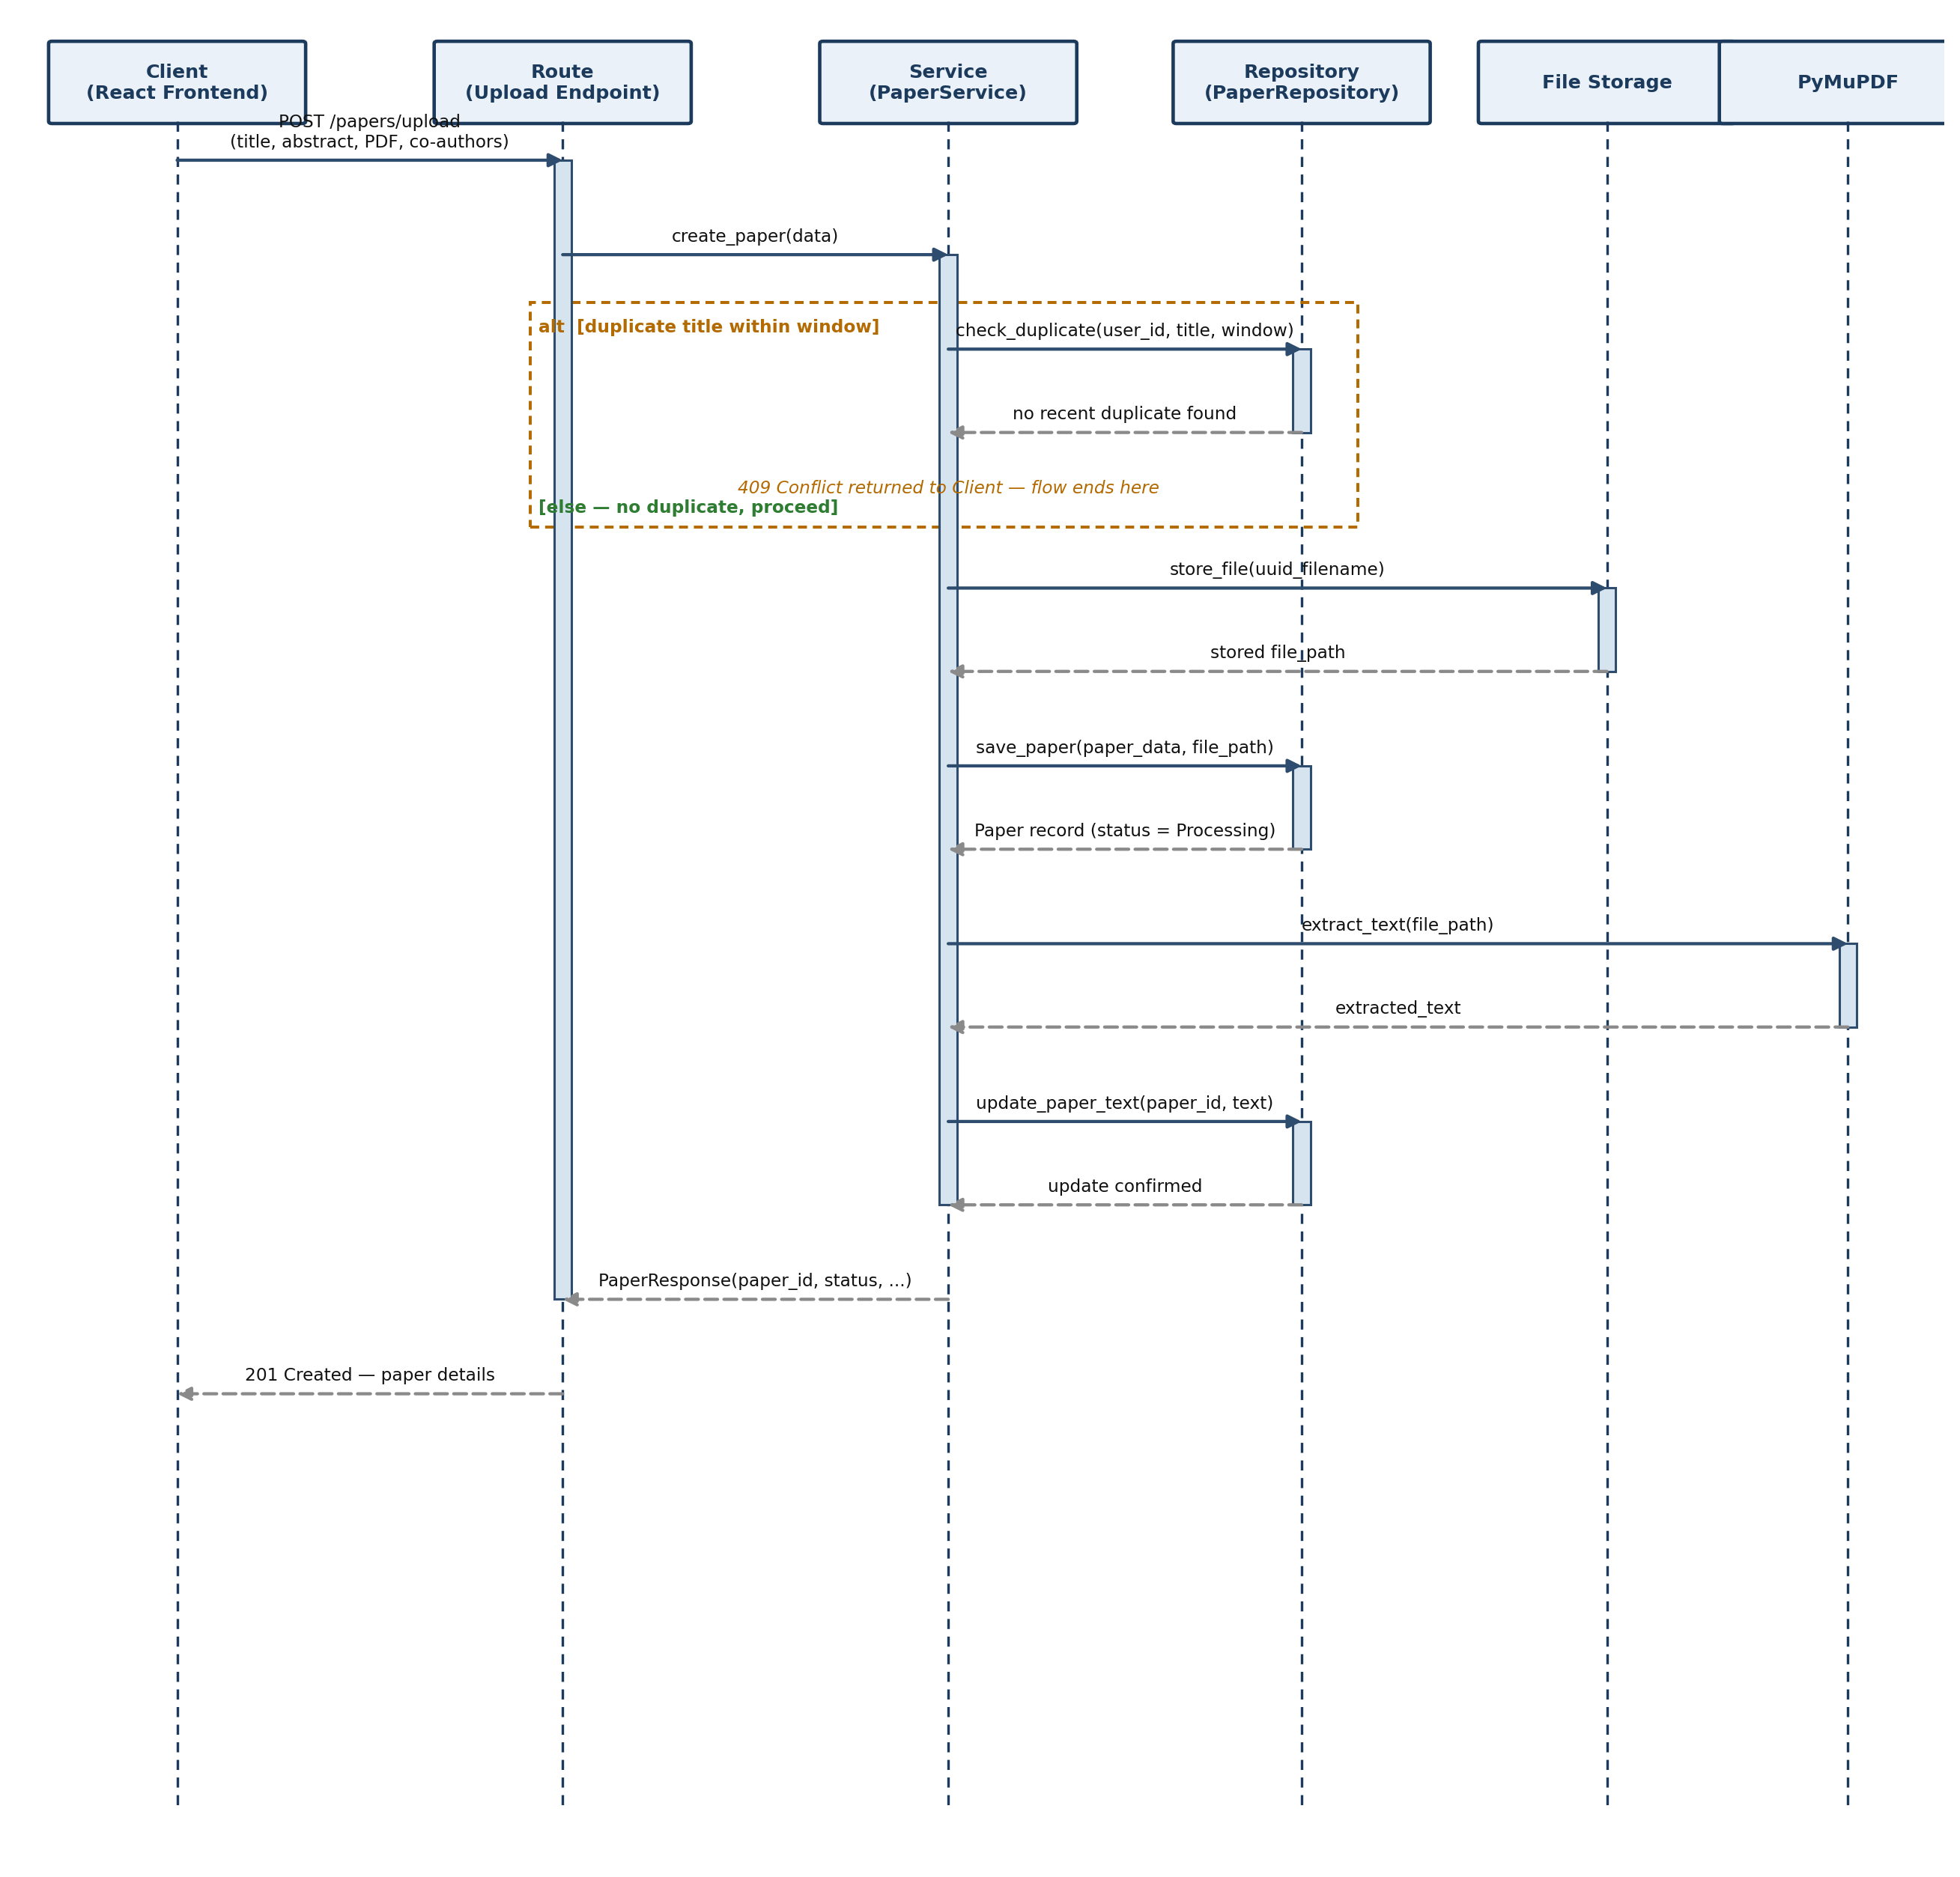
Figure 2.3: Sequence diagram for the paper upload and text-extraction flow through the Route → Service → Repository layers, including the duplicate-check, file-storage and PyMuPDF-extraction steps.

Chapter 3 Results and Evaluation

3.1 Testing Methodology
Automated backend testing uses pytest, following a red → green → refactor test-driven development cycle for the completed modules. Unit tests cover authentication, authorisation and upload-related logic in isolation, while integration-style tests exercise flows such as login, protected-route access, paper upload, PDF extraction and re-extraction, and co-author/user search. Duplicate-prevention behaviour, UUID-based file storage and deactivated-account handling are also covered.

3.2 Performance Metrics
As the project is at the mid-semester stage, the metrics available relate to test coverage of the completed modules rather than end-to-end system performance, since the asynchronous LLM pipeline that will drive topic search and collaboration has not yet been built. The table below summarises the current automated test results.
Phase / Area | Reported Result | Status
Phase 1 (foundation, auth) | 17 tests passing | Completed
Phase 2 (upload, extraction, search) | 13 tests passing | Completed
Total | 30 tests passing | Completed
LLM extraction accuracy / latency | Not yet measurable | Planned for next phase

3.3 Analysis
Against the objectives set out in Chapter 1, the foundation objectives — secure authentication, role-based access control, paper upload with co-author tagging, PDF text extraction and automated testing — have been met and are demonstrated in the current prototype, along with a professional, responsive frontend that exceeds the minimal interface originally scoped for this stage. The objectives that depend on the LLM pipeline — topic extraction, future-scope summarisation, topic-based search, and the collaboration-request/notification workflow — remain planned, since they build on the paper-upload and text-extraction foundation completed in this phase.
The main challenges encountered so far were around data integrity during upload: preventing duplicate submissions when a user re-submits the same paper, and avoiding duplicate author-association records when the same co-author is tagged across multiple uploads. These were resolved respectively through a combination of frontend submission locking with a backend recent-upload deduplication check, and get-or-create logic in the author-association service. A further practical challenge was keeping the co-author search responsive under fast typing, which was addressed by debouncing the search requests on the frontend.

Chapter 4 Conclusion

4.1 Summary of Work
At the mid-semester stage, ScholarLink has a working full-stack foundation: a FastAPI backend organised into routes, services and repositories; a PostgreSQL data model covering all eight core entities with an initial Alembic migration; JWT-based authentication with role-based access control for Student, Professor and Admin; an authenticated paper-upload pipeline with co-author tagging and PyMuPDF-based text extraction; duplicate-upload protection at both the frontend and backend; 30 automated pytest tests passing across two phases; and a redesigned, responsive React frontend covering authentication, dashboard, upload, researcher search and profile screens.

4.2 Key Findings
- A layered Route → Service → Repository backend made it straightforward to add features such as duplicate-upload protection and get-or-create author linking without touching the route layer, confirming the architectural choice made at proposal stage.
- Designing the full data model (including Topic, PaperInsight, CollaborationRequest and Notification) before building the LLM pipeline made it possible to complete and test the upload and extraction foundation independently of the AI integration work.
- Simple client-side safeguards (submission locking, debounced search) meaningfully reduced backend load and duplicate-data issues without requiring additional infrastructure.

4.3 Future Work and Recommendations
The next phase of the project will build directly on the completed foundation:
- Implement asynchronous background-job processing so that an uploaded paper's status can move from Processing to Published once analysis completes, without blocking the upload request.
- Integrate the LLM-based topic-extraction and future-scope-summarisation call, and match extracted topics against the existing Topic table before creating new ones.
- Build topic-based browse and keyword search over title, abstract and generated summary, and revisit embedding-based semantic search as a stretch goal if time permits.
- Implement the collaboration-request workflow (send, accept/decline, reveal contact details) and event-driven in-app notifications.
- Extend automated test coverage to the new LLM-extraction and collaboration-request logic, and complete the CI/CD pipeline (test → build → deploy) on GitHub Actions.

4.4 Final Remarks
The work completed to date establishes a solid, tested foundation for ScholarLink rather than a superficial demonstration: the authentication, data-model, upload and extraction layers were all built with the same architectural discipline intended for the finished system. This foundation is expected to substantially de-risk the remaining LLM-integration and collaboration-workflow work, since the entities, endpoints and testing conventions those features depend on are already in place.

Bibliography
[1] FastAPI documentation. Available at: https://fastapi.tiangolo.com
[2] React documentation. Available at: https://react.dev
[3] SQLAlchemy documentation. Available at: https://docs.sqlalchemy.org
[4] Alembic documentation. Available at: https://alembic.sqlalchemy.org
[5] PyMuPDF documentation. Available at: https://pymupdf.readthedocs.io
[6] PostgreSQL documentation. Available at: https://www.postgresql.org/docs
[7] pytest documentation. Available at: https://docs.pytest.org
[8] JSON Web Token (JWT), RFC 7519. Available at: https://www.rfc-editor.org/rfc/rfc7519

